**Associates of**

On Database

On Mailing List



Member no.:

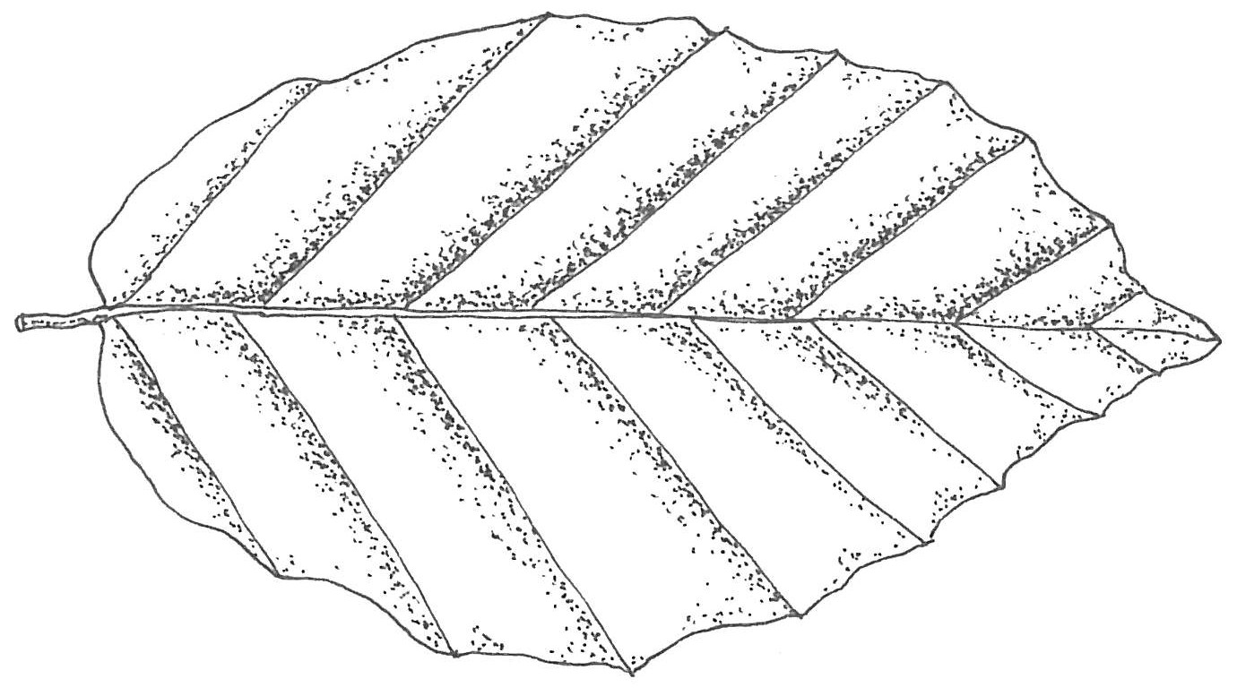

**Epping Forest Field Centre**

Patrons: Lord Graham of Edmonton, Lord Jenkin of Roding,

Lord Tebbit of Chingford CH, Mr R.S. Chapman, MBE, MA, FCA

The Associates of Epping Forest Field Centre are dedicated to raising awareness of and funds for the work in Epping Forest by the Field Studies Council (Registered Charity No. 313364). Your support will allow us to continue *‘bringing environmental understanding to all’.*

**Membership is free** however, donations to support the work of the Associates are welcome, and will be used to provide opportunities for disadvantaged children to visit the centre. To donate please visit [*www.localgiving.com*](http://www.localgiving.com) then enter *The* *Associates of Epping Forest field Centre.*

I **(Title & Full name)**………………………………………………………wish to become a member of the Associates of Epping Forest Field Centre

|  |  |
| --- | --- |
| **Postal Address:**  **Postcode:** | **Email address*:** |
| **Daytime number:** |
| **Evening number:** |
| **Mobile:** |

* You will receive a welcome email and communications from The Associates via email. Please add the following [associateseffc@yahoogroups.com](mailto:associateseffc@yahoogroups.com) to your address book.

Epping Forest Field Centre (EFFC) will hold your details on a database for use in mailings. EFFC and the ‘Associates’ will not pass your details onto any other organisation without your consent. The Committee of the Associates of Epping Forest Field Centre reserve the right to review membership status at any time.

Forms can be returned to: Epping Forest Field Centre, Pauls Nursery Road, High Beach, Loughton, Essex. IG10 4AF

On Database



On Mailing List



Member no.:

**Associates of**



**Epping Forest Field Centre**

Patrons: Lord Graham of Edmonton, Lord Jenkin of Roding,

Lord Tebbit of Chingford CH, Mr R.S. Chapman, MBE, MA, FCA

The Associates of Epping Forest Field Centre are dedicated to raising awareness of and funds for the work in Epping Forest by the Field Studies Council (Registered Charity No. 313364). Your support will allow us to continue *‘bringing environmental understanding to all’.*

**Membership is free** however, donations to support the work of the Associates are welcome, and will be used to provide opportunities for disadvantaged children to visit the centre. To donate please visit [*www.localgiving.com*](http://www.localgiving.com) then enter *The* *Associates of Epping Forest field Centre.*

I **(Title & Full name)**………………………………………………………wish to become a member of the Associates of Epping Forest Field Centre

|  |  |
| --- | --- |
| **Postal Address:**  **Postcode:** | **Email address*:** |
| **Daytime number:** |
| **Evening number:** |
| **Mobile:** |

* You will receive a welcome email and communications from The Associates via email. Please add the following [associateseffc@yahoogroups.com](mailto:associateseffc@yahoogroups.com) to your address book.

Epping Forest Field Centre (EFFC) will hold your details on a database for use in mailings. EFFC and the ‘Associates’ will not pass your details onto any other organisation without your consent. The Committee of the Associates of Epping Forest Field Centre reserve the right to review membership status at any time.

Forms can be returned to: Epping Forest Field Centre, Pauls Nursery Road, High Beach, Loughton, Essex. IG10 4AF